Typefont will be “Times New Roman” in all texts.

ARTICLE TITLE (in the article’s language with capital letters)
(14 font size, Bold, before 6pt, after 6pt, line spacing: 1,5 lines, alignment: center)

ABSTRACT
(Abstract title in the article’s language. English Abstract if the language of the study is English, Turkish Abstract if the language of the study is Turkish) (12 font size, Bold, before 6pt, after 6pt, line spacing: Single, Special: First line, By: 1,25 cm, Alignment: justified)

Abstract has to be between 100 and 150 words.
(10 font size, Italics, before 6pt, after 6pt, line spacing: single, Special: First line, By: 1,25 cm, Alignment: justified)
Keywords: 3-5 words (10 font size, Italics, before 6pt, after 6pt, line spacing: single, Special: First line, By: 1,25 cm, Alignment: justified)
JEL Codes: Minimum 2, maximum 5 codes (10 font size, Italics, before 6pt, after 6pt, line spacing: single, Special: First line, By: 1,25 cm, Alignment: justified)
https://www.aeaweb.org/econlit/jelCodes.php?view=jel

ARTICLE TITLE (Translated Title. Capital Letters)
(12 font size, Bold, before 6pt, after 6pt, line spacing: 1,5 lines, alignment: center)

ABSTRACT
(Translated abstract title. English Abstract if the language of the study is English, Turkish Abstract if the language of the study is Turkish) (12 font size, Bold, before 6pt, after 6pt, line spacing: Single, Special: First line, By: 1,25 cm, Alignment: justified)

Abstract has to be between 100 and 150 words.
(10 font size, Italics, before 6pt, after 6pt, line spacing: single, Special: First line, By: 1,25 cm, Alignment: justified)
Keywords: 3-5 words (10 font size, Italics, before 6pt, after 6pt, line spacing: single, Special: First line, By: 1,25 cm, Alignment: justified)
JEL Codes: Minimum 2, maximum 5 codes (10 font size, Italics, before 6pt, after 6pt, line spacing: single, Special: First line, By: 1,25 cm, Alignment: justified)
https://www.aeaweb.org/econlit/jelCodes.php?view=jel

Titles inside the Text
(12 font size, Bold, before 6pt, after 6pt, line spacing: 1,5 lines, Alignment: justified)
- TITLE IN CAPITAL LETTERS
Only the First Letters are Written in Capital Letters in Other Titles
Body Text (12 font size, Regular)
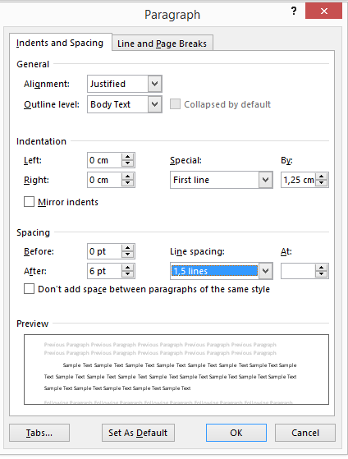

1 MLA and APA styles are used in footnotes. MLA is given in footnotes; whereas APA is used inside the body text.
(8 Font size, Regular) (Spacing: Before, After: 0pt) (Line spacing: Single, Alignment: Left)

In the display of the tables, table title will be placed over the table as “Table 1. …..” indicating the name and number of the table. Each word in the table title will start with capital letters. “Table 1.” will be written in bold, and the rest of the title will be written in regular style.
(12 font size, Bold/Regular, before 6pt, after 6pt, line spacing: Single, Alignment: Centered)
The font size in the table will be 10 or 8 and the table will be prepared to fit the page.

In the display of the figures, figure title will be placed below the table as “Table 1. …..” indicating the name and number of the table. Each word in the figure title will start with capital letters. “Table 1.” will be written in bold, and the rest of the title will be written in regular style.
(12 font size, Bold/Regular, before 6pt, after 6pt, line spacing: Single, Alignment: Centered)
The figure has to be prapared to fit the page.
The sources of the tables and figures must be mentioned below the table with 8 font size and and aligned to the left.
(8 font size, Bold/Regular, before 6pt, after 6pt, line spacing: Single, Alignment: Left)
Source: ……………………

REFERENCES
(12 font size, Bold, before 6pt, after 6pt, line spacing: 1,5 lines, alignment: justified)
References are cited in MLA or  APA style. | (10 font size, Regular, before 6pt, after 0pt, line spacing: Single, Alignment: justified)
Refererences must be cited as sorted out from A to Z according to the Authors’ surnames. Line spacing between each reference will be 1.
Coughlan, A. T. and K. Grayson (1998), “Network Marketing Organizations: Compensation Plans, Retail Network Growth, And Profitability”, International Journal of Research in Marketing, 15, 401-426

Nakip, M. (2006), Pazarlama Araştırmaları Singlenikler Ve Spss Dessingleli Uygulamalar. Ankara: Seçkin Yayıncılık.

Odabaşı, Y. ve G., Barış (2002). Tüketici Davranışı, İstanbul: MediaCat Kitapları.
PAGE SETUP OF THE STUDY MUST BE AS FOLLOWS:
